Curbstone

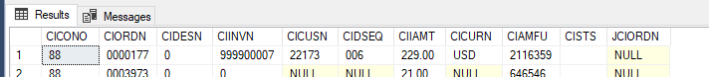

M3 Order Number -> Lookup JBA Order (in M3 Order Header) -> Check MFUKey -> Yes > Qualifies
JBA Order Number and M3 Invoice number is sent to Curbstone.

